When: 7pm May 13 – Candidates and Sponsors in their seats by 6:15pm
Presiding: Bishop Ricken
Where: St Peter the Fisherman Parish in Two Rivers.

Candidate and Family Interviews: Tom will meet with each student and their family in their homes prior to the October 19 retreat to go over the details, review the first seven days of the Wild Goose Confirmation Discernment assignment, do the prayer inventory and answer questions.

RETREAT: Students will begin the program with an onsite retreat (9a til 5p) on Saturday October 19, 2019 which will culminate in Mass from 4p to 5p on that day.

SESSIONS: The Schedule if as follows:

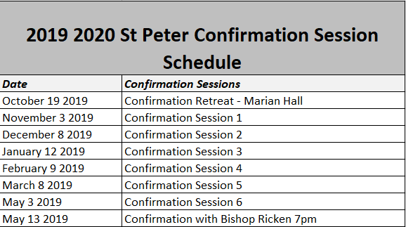

There will be three additional meetings between Confirmation Sessions with Dcn Tom Tomaszewski and the Core Group Member assigned to that student for approx. one-hour with dates and times to be mutually determined. (Virtus rules apply)

ASSIGNMENTS: There will be:

Two (2) assignments for the Student and their Sponsor to complete

Students must complete the:

- Form identifying a Sponsor
- Form identifying Confirmation Name
- Letter to the Bishop
- Signed Sheet Confirming Service Hours
  - 20 Total Service Hours
    - 10 Service to the Community and
    - 10 Service to the Church
- 5 Mass Worship Notes ( One Due Each Month)
- All Assigned Session Work
- Wild Goose Assignment
  - First Seven Days Completed Pre Retreat
- Make Up Work for any Missed Sessions

