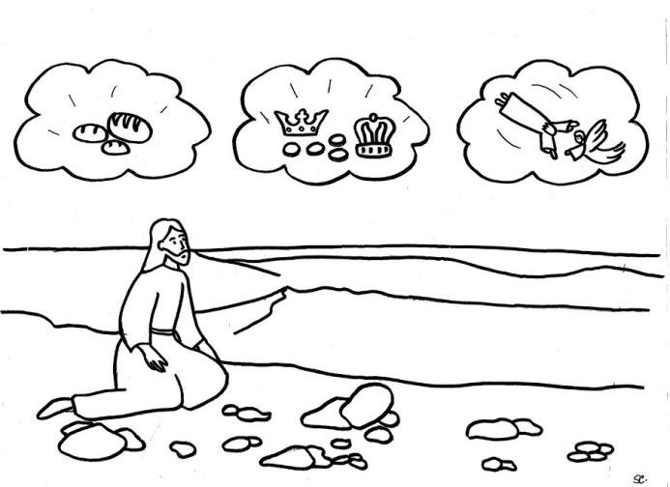

The Temptation of Jesus

Matthew 4: 1-11 New American Bible (Revised Edition) (NABRE)
^{1 [ a ]}Then Jesus was led by the Spirit into the desert to be tempted by the devil. ^{two} I have fasted for forty days and forty nights, ^{[ b ]} and afterwards he was hungry. ³ The tempter approached and said to him, “If you are the Son of God, command that these stones become loaves of bread.” ^{4 [ c ]} I said in reply, “It is written:
'One does not live by bread alone, but by every word that comes forth from the mouth of God.' ”
^{5 [ d ]} Then the devil took him to the holy city, and made him stand on the parapet of the temple, ⁶ and said to him, “If you are the Son of God, throw yourself down. For it is written:
'He will command his angels concerning you' and 'with their hands they will support you, lest you dash your foot against a stone.' ”
⁷ Jesus answered him, “Again it is written, 'You shall not put the Lord, your God, to the test.'” ⁸ Then the devil took him up to a very high mountain, and showed him all the kingdoms of the world in their magnificence, ⁹ and he said to him, “All these I shall give to you, if you will prostrate yourself and worship me . ” ^{[ e ] 10} At this, Jesus said to him, “Get away, Satan! It is written:
'The Lord, your God, shall you worship and him alone shall you serve.' ”
¹¹ Then the devil left him and, behold, angels came and ministered to him.

Footnotes:
- 4: 1–11 Jesus, proclaimed Son of God at his baptism, is subjected to a triple temptation. Obedience to the Father is a characteristic of true sonship, and Jesus is tempted by the devil to rebel against God, overtly in the third case, more subtly in the first two. Each refusal of Jesus is expressed in language taken from the Book of Deuteronomy ( Dt 8: 3 ; 6:13 , 16 ). The testings of Jesus resemble those of Israel during the wandering in the desert and later in Canaan, and the victory of Jesus, the true Israel and the true Son, contrasts with the failure of the ancient and disobedient "son," the old Israel. In the temptation account Matthew is almost identical with Luke; both seem to have drawn upon the same source.
- 4: 2 Forty days and forty nights : the same time as that during which Moses remained on Sinai ( Ex 24:18 ). The time reference, however, seems primarily intended to recall the forty years during which Israel was tempted in the desert ( Dt 8: 2 ).
- 4: 4 Cf. Dt 8: 3 . Jesus refuses to use his power for his own benefit and accepts whatever God wills.
- 4: 5–7 The devil supports his proposal by an appeal to the scriptures, Ps 91: 11a , 12 . Unlike Israel ( De 6:16 ), Jesus refuses to "test" God by demanding from him an extraordinary show of power.
- 4: 9 The worship of Satan to which Jesus is tempted is probably intended to recall Israel's worship of false gods. His refusal is expressed in the words of Dt 6:13 .
- 4: 12–17 Isaiah’s prophecy of the light rising upon Zebulun and Naphtali ( Is 8: 22–9: 1 ) is fulfilled in Jesus' residence at Capernaum. The territory of these two tribes was the first to be devastated (733–32 BC) at the time of the Assyrian invasion. In order to accommodate Jesus' move to Capernaum to the prophecy, Matthew speaks of that town as being “in the region of Zebulun and Naphtali” ( Mt 4:13 ), whereas it was only in the territory of the latter, and he understands the sea of ​​the prophecy, the Mediterranean, as the sea of ​​Galilee.

________________________________________________________________________________
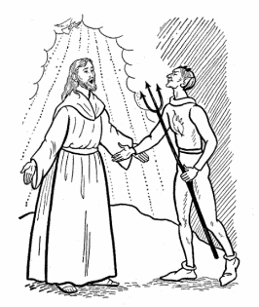
How are you tempted as Christ was tempted during His 40 days? These are examples of what might be the modern day equivalent “tempts” we might face in comparison to Christ’s temptations of pleasure, power and wealth.

- How are you tempted by pleasure, comfort or just doing what pleases you vs following the will of God?

- How tempted are you by things that feed your ego, reputation, and/or ability to increase your social standing in the group you run with?

- How tempted are you do things that bring you more stuff, activities, and activities that are expensive to participate in rather than do something simple such as pray or go to Church?

